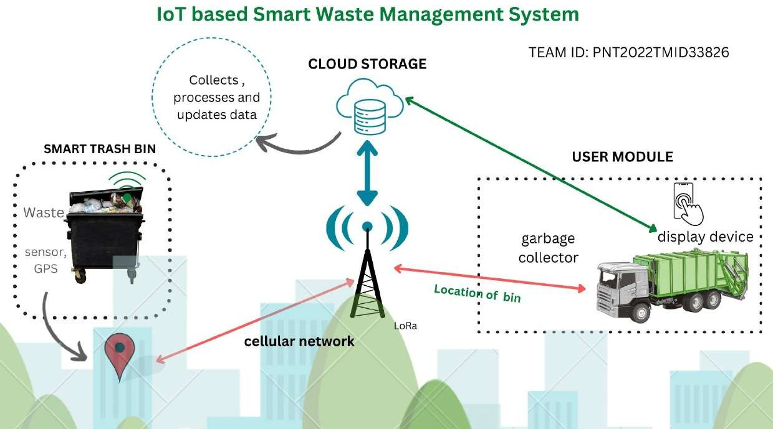

Project Design Phase-II

|  |  |
| --- | --- |
| Date | 27 October 2022 |
| Team ID | PNT2022TMID48693 |
| Project Name | SMART WASTE MANAGEMENT SYSTEM |
| Maximum Marks | 4 Marks |